THE GIANT LACHLAN OROCLINE - A POWERFUL NEW PREDICTIVE TOOL FOR MINERAL EXPLORATION UNDER COVER ACROSS EASTERN AUSTRALIA

Ross Cayley
Geological Survey of Victoria.

Abstract
Since the first applications of modern plate tectonic theory were applied to Eastern Australia, the Lachlan Fold Belt (LFB) has been repeatedly interpreted within the paradigm of an unusually wide and squat, composite orogen, an amalgamation of multiple linear, orogen-parallel Early Paleozoic accretion or rifting events and multiple arc complexes, some developed independently, some simultaneously. Such models are a poor fit to key Ordovician palaeogeographic constraints, and don’t take a highly variable mix of accretionary and intra-plate characteristics, or microcontinents embedded within the orogen, into account. The integration of modern structural and stratigraphic mapping with aeromagnetic, gravity and deep seismic reflection data and geochronology now constrains a new geodynamic model: a simple unifying solution for the whole LFB from far north Queensland to Tasmania. This model develops the idea that only one, continent-dipping, subduction zone was active in eastern Australia in the Ordovician-Early Devonian. A narrow, linear arc – the Macquarie Arc – was constructed above this zone during a period of trench-stability that spanned the Ordovician. The Macquarie Arc and associated rocks became accreted to eastern Australia as the Lachlan Orogen during transient end-Ordovician trench-advance (the Benambran Orogeny) which was precipitated by the sinistral-oblique collision of the microcontinent Vandieland (Tasmania and the Selwyn Block) into the southern end of the subduction zone. This collision precipitated a tectonic mode-switch to asymmetric trench-retreat, which persisted throughout the Silurian. The Lachlan Orogen experienced widespread rifting, oceanward arc-migration, and mega-folding about vertical axes, all within a dextral trans-tensional upper-plate setting that chased the Paleopacific slab retreating oceanward in asymmetric southeast-directed roll-back. Mega-folding reoriented the Lachlan Orogen into a giant Z-shaped orocline that wrapped around the northern and eastern margins of the microcontinental collider. The Lachlan Orocline core is 400-1200 km in amplitude with well-defined limbs enclosing a fault-disrupted and extended core. Its formation involved continent-scale reorientations of the geology and effectively doubled apparent LFB width, disrupting and redistributing any- and all- mineral systems formed within the orogen prior to 400Ma in the process. Today, the Lachlan Orocline gives the appearance of ‘multiple’ coeval accretionary systems of opposing dip when simple cross-sections are constructed across it. This is simply a function of the large-scale of refolding.
The new model explains: patterns in aeromagnetic data; long-standing paleomagnetic data complexity; palaeogeography; provenance and stratigraphic relationships; apparent structural vergence ‘reversals’; the transition to Silurian crustal extension and rejuvenated marine sedimentation, onset of high-T back-arc metamorphism, and the wave of Silurian/Early Devonian arc- and back-arc magmatism that swept the LFB. The model delivers insight into the dynamics of the transfer of continental colliders from the lower to upper plate of a persistent subduction system and provides a new geodynamic model for the Cambrian-Devonian evolution of Tasmania in the process. It’s a brand new conceptual template for predicting the location of buried mineral systems in all of Australia’s eastern States, with a 3-fold+ increase in the area of potentially prospective rocks that are directly comparable to those already known, from beneath the vast plains of southern Queensland to the highlands of Tasmania. New locations predicted beneath younger cover are now available for targeted regional mineral exploration – a stimulant for the search for the next generation of mineral deposits in Australia. This result illustrates the power of deep integration of geodynamic modelling with other strands of geoscience. The proven concept of scale invariance – the multi-scale manifestation of process and structure in geology – means that this continent-scale structural solution can be down-scaled for use as a structural template to solve, or test complex geological scenarios at province, camp- and the mineral-deposit scale. Eastern Australia is now the global type-locality for a new geodynamic model that rethinks the mantle processes that drive continental collisions.

Introduction
Exposed or geophysically expressed minerals deposits can be found and developed without requiring a deep understanding of the overarching geodynamic system and potentially related mineral system. Buried or otherwise cryptic mineral deposits cannot – the odds of random success are too small.
The mining history of Australia bears out this truth – virtually all significant mineral discoveries have been made in – or adjacent to – regions of outcrop, or are buried but have distinctive geophysical character. That cupboard is now quite bare. The challenge in making big new discoveries and gaining a complete understanding of a cryptic mineral system is the younger cover. Deep understanding is required to make this style of mineral exploration effective. This is the challenge driving recent research by all the State Geological Surveys (and UNCOVER a host of other research organisations).
Over the last 2 decades, modern geoscience across Eastern Australia and the explosion in understanding of global geodynamics and computing power has combined to put us on the threshold of a true revolution in understanding the geology, tectonic evolution, and therefore mineral prospectivity of the Tasmanides and beyond. Victoria contributes a vital part to this story. Victoria’s physical size is small but, uniquely, the Great Dividing Range is orientated east-west across virtually the whole State, exposing the full width of the Lachlan and eastern Delamerian fold belts to modern detailed geological investigations, now nearly complete (eg. VandenBerg et al., 2000; Cayley et al, 2011; Rawling et al., 2012). This Victorian Palaeozoic geology transect is a fundamental constraint against which all new tectonic models for the Tasmanides, from far north Queensland to Tasmania, with the Alice Springs Orogen thrown in, must be measured.
Recent detailed regional aeromagnetic data and orogen-scale deep seismic reflection transects have allowed Victorian constraints to be expanded into adjacent States, with eye-popping results you couldn’t otherwise anticipate – the giant Lachlan Orocline. This research has resulted in a cascade of radical new understandings growing to incorporate the furthest reaches of the Tasmanides. It has gained support and geodynamic context from independent studies at Monash University, led by Prof. Louis Moresi (Moresi et al. 2014). This new understanding has huge implications for mineral prospectivity across Victoria, NSW, Queensland, Tasmania and parts of SA and the NT, some of which are briefly reviewed.

A brief history of the Tasmanides
Geochemistry and magmatic history (Crawford, 1978; Kemp, 2003; Foden et al., 2006) geophysics and structural history (Cayley & Taylor, 2000; Greenfield et al., 2011, Cayley et al., 2011a and in prep.), geochronology and P-T characteristics of metamorphism (Miller et al., 2005) constrain a continental margin magmatic arc-setting for the eastern Delamerian Orogen along East Gondwanaland through the Cambrian. This is different to earlier ideas that envisaged an arc-continent collision of opposite geometry (eg. VandenBerg et al., 2000). Some researchers persist with the earlier idea (eg. Gibson et al, 2011). The remnants of this continental margin system are exposed in far western Victoria as an inverted back-arc basin – the Glenelg Zone, the overthrust and partly buried Stavely Arc complex itself (in the Grampians-Stavely Zone) and, farther east, an adjacent coeval accretionary wedge – the Stawell Zone (Cayley et al., 2011b), We now interpret all these elements to have formed above a persistent continent-dipping subduction zone active from ~520+ - 500 Ma.
At the end of the Cambrian, this single elongate arc system became disturbed and, in Australia, shortened, accreted, stalled and extinguished – the Delamerian Orogeny (Tyennan Orogeny in Tasmania). Extinguishment in Victoria involved the system evolving from a Japanese- to Andean-style geometry, probably a consequence of shallowing and congestion of the underlying subduction zone in response to the oblique arrival and collision of an exotic micro-continent just to the south – Vandieland (Cayley, 2011).
In Australia, extinguishment of Cambrian subduction along the continent margin coincided with the appearance of a brand new subduction system farther outboard that was able to take up the ongoing Pacific-Gondwanaland sinistral-oblique plate-boundary convergence – this ‘new’ system was the intra-oceanic Ordovician Macquarie Arc system – a single, linear arc when active. The collision of Vandieland into the Gondwana margin triggered this Cambro-Ordovician change, and this ‘Delamerian’ event represents the first of several dramatic ‘tectonic mode switches’ (Collins, 2002a; Lister & Forster, 2009) we have now recognised in the Tasmanides of eastern Australia. The Delamerian mode switch represents a pronounced change from strong Cambrian convergence against the Gondwanaland margin – the Delamerian Orogeny – to Ordovician translation and ‘tectonic escape’ of Vandieland oceanwards, as it re-emerged from it’s site of Delamerian collision (Cayley, 2011). This concept is still somewhat controversial, but is important for understanding mineral prospectivity because this switch is marked by a pulse of mineralised magmatism within the Stavely Arc.
Following its re-emergence from the ‘Delamerian’ continental margin, Vandieland was drawn inexorably towards the southernmost end of the Macquarie Arc system throughout the Ordovician (Cayley, 2011), with which it eventually – and inevitably – collided at the end of the Ordovician.
Throughout the Ordovician, the proto-Lachlan Fold Belt accumulated vast volumes of siliciclastics – the Castlemaine and Adaminaby Supergroups – which were deposited in huge submarine turbidite fans that encircled the active Macquarie Arc (Fergusson, 2009). Some parts of the fan deposited in an intraplate setting south of the arc, a region that was probably undergoing slow progressive shortening adjacent to the Vandieland escape transform (eg. the Bendigo Zone; Gray et al., 2006; Cayley, 2011; Cayley et al, 2011b). Some parts were deposited in the back-arc between the Macquarie Arc and the Gondwana coast (the proto Wagga-Omeo Zone), and some parts were deposited in an adjacent accretionary setting (eg. Miller & Gray, 1996), in front of the Macquarie Arc (the proto-Mallacoota Zone). The Lachlan Orocline model advocates for different paleogeographic contexts between these regions, explaining important distinctions in depositional history and structural character, and some other curious aspects of Late Ordovician sedimentology, in a way not previously possible.
Towards the end of the Ordovician, all these rocks were shortened, thickened, uplifted and accreted to the eastern edge of Gondwanaland to form the Lachlan Fold Belt – the Benambran Orogeny. The sinistral-oblique approach of Vandieland into the southern end of the Macquarie Arc subduction zone, and consequent shallowing of the slab, is implicated as the driver of this upper (Gondwanaland) plate convergence. Once again Vandieland, including western Tasmania, appears to have been the ‘wrecking ball’ disrupting an otherwise meta-stable convergent plate-boundary system.
Final microcontinent collision and congestion of the southern Macquarie Arc subduction zone appears to have occurred around 440 Ma, and this is the time of a second dramatic tectonic mode switch within the Tasmanides (Moresi et al., 2014). This switch was from trench advance and associated upper plate shortening during the Benambran Orogeny, to asymmetric trench retreat and upper plate extension and collapse – the Silurian Bindian Orogeny – into a gravitational potential well that was chasing the uncongested portions of the lower plate slab adjacent to Vandieland in rapid asymmetric rollback into the Paleopacific Ocean. This switch is also important for understanding mineral prospectivity, because it provides a geodynamic context for the pulse of mineralised porphyries that intruded the Macquarie Arc at ~440Ma.
Throughout the Binidan Orogeny, slab rollback became increasingly asymmetric. This was a direct consequence of the Vandieland Microcontinent which remained embedded into the lower plate, and effectively pinned the southern end of the retreating slab. With the remainder of the slab remaining uncongested and in free roll-back, a clockwise rotation developed farther outboard, progressively forming the Lachlan Orocline (Cayley, 2012; Figure 1). The once-linear Macquarie Arc – and all the mineral systems developed within it up to ~440 Ma – was torn into a number of segments at this time. Some parts were internally rifted (for example the Hill End Trough), while other parts were juxtaposed across strike-slip faults (Packham, 1987). Most of the arc segments were drawn southwards into the core of the Lachlan Orocline as its amplitude continued to grow. The southernmost arc segment – the Hay-Booligal Zone adjacent to the site of Vandieland collision – remained trapped behind the microcontinent.

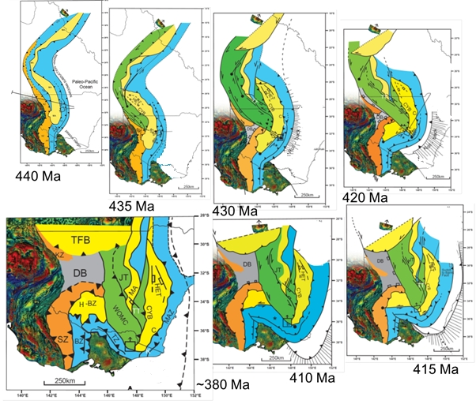
Figure 1: Palinspastic map sequence depicting the evolution of the mainland Lachlan Fold Belt from the culmination of the Benambran Orogeny at 440 Ma to the end of the Tabberabberan Orogeny at ~380 Ma. Tilt-filter aeromagnetic data= Proterozoic-Cambrian craton and northern Vandieland. SZ=Stawell Zone, KZ=Kayrunnera Zone, BZ=Bendigo Zone, TZ=Tabberabbera Zone, MAZ=Mallacoota Zone, MA=Macquarie Arc, H-BZ=Hay-Booligal Zone, TFB=(southern) Thomson Fold Belt, WOMZ=Wagga-Omeo Metamorphic Complex/Zone, DB=Darling Basin, JT=Jemalong Trough, HET=Hill End Trough, TT=Tumut Trough, CYB-Canberra-Yass Basin, C=Cooma Complex, K=Kuark Metamorphic Complex. Orange= Cambrian accretionary wedge. Yellow=Ordovician intraoceanic arc. Blue= deformed Ordovician marine siliciclastic successions. Green= Silurian metamorphic terranes. Grey= Siluro-Devonian back-arc basin

Discussion

Tectonic Mode Switches in the Tasmanides
Tectonic ‘mode switches’ are recognised as key to world-class mineral endowment. Steady-state magmatic arcs and other geological systems tend to disperse rather than concentrate metals. In contrast, episodic activity is implicated in the economic concentration of metals and their delivery to surface (eg. Vos et al., 2007).
Episodicity in the Tasmanides is revealed as the main orogenic ‘events’, with transient convergent episodes followed by a discrete ‘pulses’ of metalliferous magmatic activity; the Stavely Arc porphyry and magmatic hydrothermal ‘event’ at ~500+/- 5 Ma in western Victoria (and along strike in western NSW and western Tasmania), and the Macquarie Arc porphyry and magmatic hydrothermal event at ~ 440 +/- 5 Ma within the Macquarie Arc (eg. Glen et al., 1998; Cooke et al., 2007).
The ‘Vandieland’ and ‘Lachlan Orocline’ models provide a new and tightly constrained geodynamic context for both these discrete pulses of metalliferous shoshonitic magmatism. This understanding provides context and incentive for persistent exploration of Stavely and Macquarie Arc fragments.
In the lead-up to both the Delamerian and Benambran mode switches, upper plate shortening was apparently caused by the approach and then collision of Vandieland into the active subduction zone. On each occasion, this appears to have shallowed the slab, imposing convergent stresses across each arc in turn, as seen by the convergent structural histories preserved in the rock record. In both cases, convergent stress would have constricted arc plumbing systems, supressing arc-magmatism. During these successive hiatuses, arc magmas trapped at depth continued to fractionate and evolve, concentrating metals.
In both cases, the key trigger for mineralisation appears to have been abrupt stress release due to post-collision plate boundary reconfiguration; in the Gondwanaland margin system at ~ 500+/- 5 Ma with a profound plate-boundary position shift (Ordovician - Cayley 2011), and subsequently in the outboard Macquarie Arc system at ~440 Ma with a switch to plate-boundary rollback (Silurian; eg. Collins, 2002a).
In both cases, stress-relief re-opened arc plumbing systems, and facilitated the introduction of a fresh pulse of pent-up magmas into the arcs. In both cases, decompression melting of the underlying metasomatised mantle wedge was probably also an important contributor to this metalliferous magmatism (eg. McInnes et al., 1999; Stillitoe 1997).
This orogen-scale model provides understanding that encourages mineral exploration of all segments of the Stavely and Macquarie Arcs, not just the portions adjacent to known mineral discoveries.

Extent of Lachlan Orocline influence
The idea that upper-crustal behaviour can be used as a proxy for understanding underlying asthenospheric flow gradients has become entrenched in the literature (eg. Collins, 2002a, b; Hamilton, 2007; Moresi et al., 2014). The Ordovician – Devonian was a particularly dynamic period for the whole Australian continent, and the Lachlan Orocline can deliver wide-ranging insights into underlying asthenosphere flow behaviour, the nature of the mantle-systems in operation at that time, and allow for interpretation of their lateral extents.
As the magnitude of Bindian slab-rollback in the core of the Lachlan Orocline grew beyond 1000km, increasingly huge volumes of asthenosphere would have been required to flow laterally into the region above the foundering slab. Although much asthenosphere may have flowed through a 'slab window' (Moresi et al., 2014), we conclude that asthenosphere was also progressively recruited from farther and farther north beneath the upper plate. The evidence for this is preserved in the linked Siluro-Devonian transtensional history of the whole Tasmanides crust, including outliers in North Queensland and beyond, much of which was rafted slowly south along a distributed network of strike-slip and extensional structures (Figure 2).

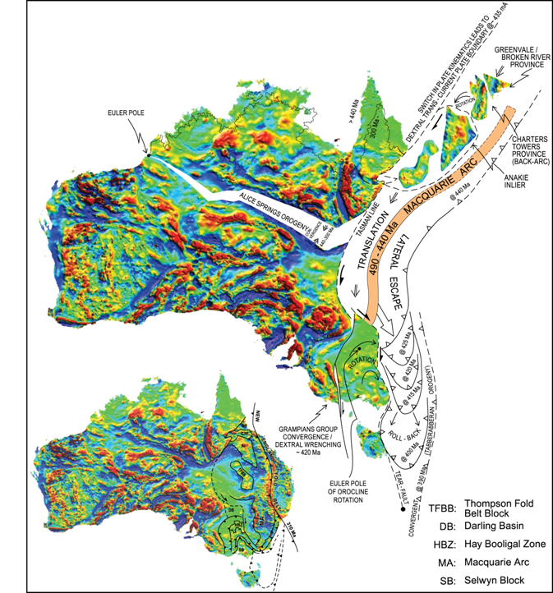
Figure 2: The Lachlan Orocline in Eastern Australia. Tracking evolution of the convergent East Gondwana-Paleopacific plate margin from the ~440Ma collision of Vandieland (Tasmania plus the Selwyn Block - SB), to it’s folded arrival in NE Tasmania around ~400 Ma. Persistent southerly asthenospheric flows in the parts of the upper plate orogen most distal to the foundering, retreating and folding slab explain the longer duration of southerly convergence in the Alice Springs Orogen and beyond. AI = Anakie Inlier, CTP = Charters Towers Province, GP = Greenvale/Broken River Province.

The average flow rates within the asthenosphere that chased the orocline beneath the LFB and beneath northern Australia were apparently always slow - no more than a few centimetres per year (the eastern LFB was translated between ~400 – 1200 km south into the orocline core over ~35 million years).
This understanding provides a geodynamic link from the Lachlan Fold Belt into the long-lived Alice Springs Orogeny. It also provides a geodynamic link into Tasmania, where final transfer of the microcontinent Vandieland onto the upper plate of the Gondwana-Pacific plate active margin is preserved in the rock record as a tight Early Devonian orocline – the Dundas-Fossey Orocline – and associated crustal fragmentation that has imparted enormous apparent complexity into the Proterozoic-Ordovician geology. The Lachlan Orocline model provides the regional context for retro-deformation of this Tasmanian complexity, revealing a new simplified pre-Silurian configuration which has huge implications for the (re)interpretation of Cambrian and pre-Cambrian tectonics and associated mineral systems.
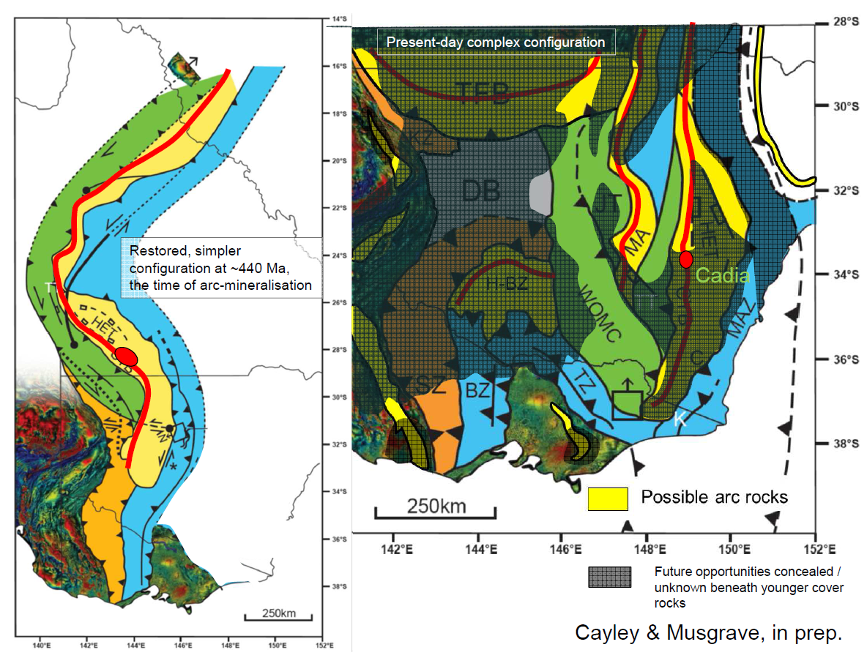
Figure 3: The Macquarie Arc (in yellow) in Eastern Australia, at ~440Ma, the time of mineralised porphyry emplacement (note position of Cadia deposit cluster as red ellipse), and probable axis of magmatism (red line), and today (on right). Note that most of the arc segments are buried beneath younger cover (grey shading), and some (eg. Hay-Boolical Zone and so-called Thomson Fold Belt) are virtually completely covered and untested. The older and narrower Stavely/Mount Wright Arc is also depicted in yellow in the right-hand diagram.

Reconstructing the Tasmanides for mineral explorers
The Lachlan Orocline model shows how it is possible for long, linear, narrow and simple magmatic arc systems active in the Cambrian (Stavely Arc (Victoria); Mt Wright Arc (NSW); Mount Read Volcanics (Tasmania) and in the Ordovician (Macquarie Arc) to have been mineralised and then subsequently dismembered and refolded during formation of the Siluro-Devonian Lachlan Orocline.
The largest-scale disruption occurred to the Macquarie Arc, with fragments dispersed widely throughout a radically-reshaped Orogen. The fragments that crop out at surface – Rockley-Gulgong, Molong-Kiandra and Parkes-Narromine Belts – have long been recognised as highly prospective. The new model shows how these may have been configured adjacent (Rockley-Gulgong-Molong-Kiandra) and along-strike (RGMK – Parkes-Narromine) to one-another at their time of formation, and highlights several other fragments that have (a) not previously been recognised as parts of the Macquarie Arc (eg the Hay-Booligal Zone), or (b) have been (eg. Burton, 2010), but with significant uncertainty to context or mineral prospectivity (eg. Southern Thompson Fold Belt) or (c) extensions into regions not previously able to be explained (eg. beneath the Deddick Zone of NE Victoria) – see Figure 3.
Siluro-Devonian disruptions to the Cambrian Stavely Arc and the Mount Read Arc are of smaller scale, but of similar style. In Victoria, this reflects transpressional and then transtensional reactivation along the Delamerian-Lachlan margin during Lachlan Orocline formation. Constraints from the Lachlan Orocline model provide a structural template that can be used to restore disrupted and folded Stavely Arc segments to reveal a much simpler Cambrian configuration, allowing for improved correlation between belt segments. Timing constraints here are given by deformation in the Silurian Grampians Group cover succession (Cayley & Taylor, 1997).
In Tasmania, the Dundas-Fossey Orocline refolds the Dundas Trough, re-distributing Cambrian Mount Read Arc volcanics and associated rocks across Tasmania. Corbett & Turner (1989) suggested that the parallelism of curved trends in the ‘Dundas-Fossey arc’ and lithological trends in the adjacent Precambrian Tyennan Block show the bend to be superimposed, and therefore likely to be Devonian.
The Lachlan Orocline model and multiple tectonic mode-switch models provide a rationale for persistent mineral exploration beneath cover for Stavely, Mount Read, and Macquarie Arc systems, and even helps decide where within these belts to explore (for example, the western flank of the restored Macquarie Arc appears the most prospective; the locus of extensional c

References
Burton, G.R., 2010. New structural model to explain geophysical features in northwestern New South Wales: Implications for the tectonic framework of the Tasmanides. Australian Journal of Earth Sciences 57, 23-49.
Cayley, R.A., 2011. Exotic crustal block accretion to the eastern Gondwanaland margin in the Late Cambrian – Tasmania, the Selwyn Block, and implications for the Cambrian-Silurian evolution of the Ross, Delamerian and Lachlan Orogens. Gondwana Research 19, 628 – 649.
Cayley, R.A., 2012. Oroclinal folding in the Lachlan Fold Belt: consequence of southeast-directed Siluro-Devonian subduction rollback superimposed on an accreted Ordovician arc assemblage in eastern Australia. In: The Great East-Australian Arm-Wave of 2012: Tectonics, Modern Analogues/Events, Mineralisation (GAGA 2012) (ed. White, S.) 34–43 (Selwyn Symposium of the GSA Victoria Division, Geological Society of Australia Extended Abstract 103, 2012).
Cayley, R.A., Korsch, R., Kennett, B, Skladzien, P., Jones, L, Morand, V.J., Gibson, G. & Rawling, T.J., & Betts, P. G., 2011a. Results of deep seismic reflection imaging of the eastern Delamerian Orogen, South Australia and western Victoria, Australia. Data CD version: 4 March, 2011. GeoScience Victoria, Department of Primary Industries.
Cayley, R.A., Korsch, R.J., Moore, D.H., Costelloe, R.D., Nakamura, A., Willman, C.E., Rawling, T.J., Morand, V.J., Skadzien, P.B. & O’Shea, P.J., 2011b. Crustal architecture of central Victoria: results from the 2006 deep crustal reflection survey. Australian Journal of Earth Sciences 58, 113 – 156.
Cayley, R. A. & Taylor, D. H. 1997. Grampians special map area geological report. Geological Survey of Victoria Report 107.
Cayley, R. A. & Taylor, D. H. 2001. Ararat 1:100 000 map area geological report. Geological Survey of Victoria Report 115.
Collins, W.J., 2002a. Hot Orogens, tectonic switching and creation of continental crust. Geology 30, 535-538
Collins, W.J., 2002b. The nature of extensional accretionary orogens. Tectonics 21, 6-1 to 6-12.
Collins, W.J. & Hobbs, B.E., 2001. What caused the Early Silurian change from mafic to silicic (S-type) magmatism in the eastern Lachlan Fold Belt? Australian Journal of Earth Sciences 48, 25-41.
Cooke, D.R., Wilson, A.J., House, M.J., Wolfe, R.C, Walshe, J.L., LIckfold, V. & Crawford, A., 2007. Alkalic porphyry Au-Cu and associated mineral deposits of the Ordovician to Early Siluirian Macquarie Arc, New South Wales. Austrlaian Journal of Earth Sciences 54, 445 – 463.
Corbett, K.D. & Turner, N.R. 1989. Early Palaeozoic deformation and tectonics, in: Burrett, C. F. & Martin, E. L. (ed.). Geology and Mineral resources of Tasmania. Spec. Pub. Geol. Soc. Aust. 15:154-181.
Fergusson, C.L., 2009. Tectonic evolution of the Ordovician Macquarie Arc, central New South Wales: arguments for subduction polarity and anticlockwise rotation. Australian Journal of Earth Sciences 56, 179–194.
Foden, J. D., Elburg, M.A., Dougherty-Page, J., & Burtt, A., 2006. The Timing and Duration of the Delamerian Orogeny: Correlation with the Ross Orogen and Implications for Gondwana Assembly. The Journal of Geology, 114, 189 – 210
Gibson, G.M., Morse, M.P., Ireland, T.R., Nayak, G.K., 2011. Arc–continent collision and orogenesis in western Tasmanides: Insights from reactivated basement structures and formation of an ocean–continent transform boundary off western Tasmania. Gondwana Research 19, 608–627.
Gray, D. R., Willman, C. E. & Foster, D. A. 2006. Crust restoration for the western Lachlan Orogen using the strain-reversal, area balancing technique: implications for crustal components and original thicknesses. Australian Journal of Earth Sciences 53, 329–341.
Glen, R.A., Walshe, J.L., Barron L.M. & Watkins, J.J. 1998. Ordovician convergent-margin volcanism and tectonism in the Lachlan sector of east Gondwana. Geology 26, 751-754
Greenfield, J.E., Musgrave, R.J., Bruce, M.C., Gilmore, P.J. & Mills, K.J., 2011. The Mount Wright Arc: A Cambrian subduction system developed on the continental margin of East Gondwana, Koonenberry Belt, eastern Australia. Gondwana Research 19, 650 – 669.
Hamilton, W.B., 2007, Driving mechanism and 3-D circulation of plate tectonics, in Sears, J.W., Harms, T.A., and Evenchick, C.A., eds., Whence the mountains? Inquiries into the evolution of orogenic systems: A volume in honor of Raymond A. Price: Geological Society of America Special Paper 433, p. 1-25.
Kemp, A.I.S., 2003. Plutonic boninite-like rocks in an anatectic setting: tectonic implications for the Delamerian Orogen in southeastern Australia. Geology, 31, 371 - 374.
Lister, G & Forster, M., 2009. Tectonic mode switches and the nature of orogenesis. Lithos 113, pp. 274 -291.
McInnes, B.I., McBride, J.S., Evans, N.J. Lambers, D.D. & Andrew, A.S., 1999. Osmium isotope constraints on ore metal recycling in subduction zones. Science 286, 512 -516
Miller, J. Mc. L. & Gray, D.R., 1997. Subduction related deformation and the Narooma anticlinorium, eastern Lachlan Fold Belt. Australian Journal of Earth Sciences 44. 237-251.
Miller, J. McL., Phillips, D., Wilson, C.J.L. & Dugdale, L.J., 2005. Evolution of a reworked orogenic zone: the boundary between the Delamerian and Lachlan fold belts. Australian Journal of Earth Sciences, 52, 921 - 940.
Moresi, L., Betts, P.G., Miller, M.S. & Cayley, R.A., 2014. Dynamics of continental accretion. Nature. doi:10.1038/nature13033
Packham, G.H., 1987. The eastern Lachlan fold belt of southeast Australia. A possible Late Ordovician to Early Devonian sinistral strike slip regime. IN: Leitch E.C. & Scheibner, E. eds. Terrane Accretion & Orogenic BGelts,, 67 – 82, AGU Geodynamic Series 19.
Rawling, T.J., Osborne, C.R., McLean, M.A., Skladzien, P.B., Cayley, R.A. & Williams, B., 2011. 3D Victoria Final Report. GeoScience Victoria 3D Victoria Report 14. Department of Primary Industries.
Reed, A. R., 2001. Pre-Tabberabberan deformation in eastern Tasmania: a southern extension of the Benambran Orogeny. Australian Journal of Earth Sicences 48, 785 – 796
Stillitoe, R.H., 1997. Characteristics and controls of the largest porphyry copper-gold and epithermal gold deposits in the circum-Pacific region. Australian Journal of Earth Sciences 44, pp. 373-388.
VandenBerg, A. H. M., Willman, C. E., Maher, S., Simons, B. A., Cayley, R. A., Taylor, D. H., Morand, V. J., Moore, D. H. & Radojkovic, A. 2000. The Tasman Fold Belt System in Victoria. Geological Survey of Victoria Special Publication.
Vos, I.M.A., Bierlein, F.P., Phillips, D. 2007, 'The Palaeozoic tectono-metallogenic evolution of the northern Tasman Fold Belt System, Australia: Interplay of subduction rollback and accretion', Ore Geology Reviews, 30, pp. 277-296.

